Understand how a canola plant grows and how growth can be affected by different management to make effective management decisions. Effectiveness of post-emergence inputs-such as herbicides, fertilizers and water-differs with stage of growth. Proper timing of application, based on growth stage of the crop, can improve the efficiency of the input and prevent crop injury and economic loss.
The growth and development of a canola plant is continuous but can be divided into easily recognizable growth stages. The length of each growth stage is greatly influenced by temperature, moisture, light (day length), nutrition and variety. Research studies at the University of Manitoba, in Winnipeg, MB have shown that temperature is the most important environmental factor regulating growth and development of canola in western Canada.
A standardized growth stage scale developed by BASF, Bayer, Ciba-Geigy and Hoechst called the BBCH decimal system provides an accurate and simplified approach to describing canola growth stages. The BBCH decimal system is illustrated in Figure 1.
Figure 1. Growth Stages in B. campestris and B. napus
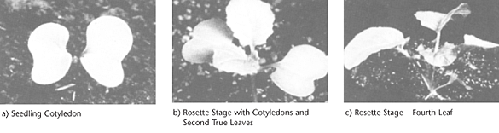
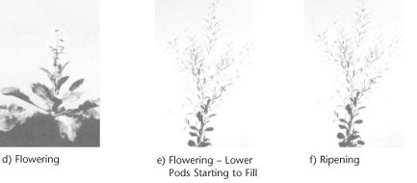
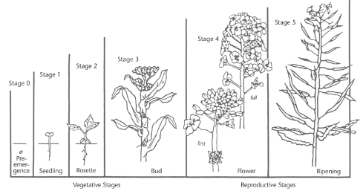
00 | dry seed (seed dressing takes place at this stage)
01 | seed imbibition (water absorption)
03 | seed imbibition complete
05 | radicle (root) emerges from seed
06 | elongation of root, formation of root hairs and/or lateral roots
07 | hypocotyl with cotyledons break though seed coat
08 | hypocotyl with cotyledons grow toward soil surface
09 | cotyledons break through soil surface
The oil and protein in the seed provide the energy required for germination but the seedbed must supply sufficient water, oxygen and a suitable temperature for germination to occur.
Water absorption is the first step in germination. Water is the medium and reactant for many biochemical processes. For a canola seed there is an initial period of rapid water uptake, followed by a lag period then rapid absorption associated with embryo growth. Since water comes from the soil, the seed must be in close contact with moist soil particles to absorb water. Water absorption by seed cells is influenced by the concentration of inorganic salts and/or organic substances in the soil solution. If the salt concentration is too high, the seed cannot absorb enough water for normal germination. This partially explains why seed may fail to germinate in the fertilizer zone or in severely saline soils.
Sufficient oxygen must be present for cell respiration to provide adequate energy for germination. Normally, oxygen is a limiting factor only under conditions leading to lower oxygen diffusion rates, such as waterlogged or compacted soils. Temperature must be within a suitable range for germination. While water absorption by the seed is not sensitive to temperature, new growth is temperature dependent because of the effect of temperature on biochemical processes.
Germination is a step-by-step process that includes:
- taking in water
- activation and synthesis of enzymes
- breakdown of stored food
- transport of breakdown products within the embryo
- initiation of embryo growth
During the period of water absorption, several enzyme systems are activated in the embryo, which break down stored proteins to amino acids, starch to glucose and oil to fatty acids and glycerol. These breakdown products are transported to the active growing point in the seed where they are rebuilt into compounds (proteins, lipids, etc.) necessary for embryo growth with the resulting swelling, splitting of the seed coat and emergence of the root or radicle tip (Figure 2).
Figure 2. Germination
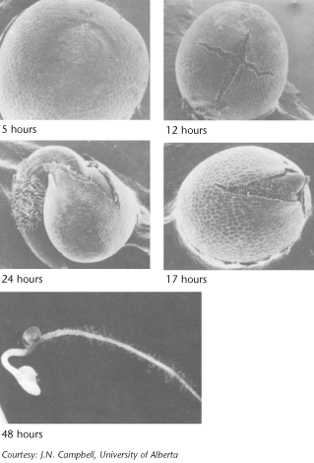
The root grows downward and develops root hairs that anchor the developing seedling. The new stem, or hypocotyl, begins growing up through the soil pushing two heart shaped leaf-like organs called cotyledons or seed leaves. The seed coat is usually shed in the process. Canola seeds have two cotyledons and canola plants are called dicotyledonous. When exposed to light, the cotyledons unfold and become green.
Other factors that influence germination are seed viability, seed size, soil microorganisms, seed soundness and seed diseases. Viability describes whether the embryo is alive and able to germinate. Seed size is an indication of the amount of food available to the seedling. Larger seeds with increased food supply frequently germinate faster, emerge from greater soil depths and produce a more vigorous seedling than do smaller seeds. Soil microorganisms can decay seeds, especially under poor germinating conditions. Seed treatments may help protect the seed and seedling against soil-borne disease infection. Cracks in the coat increase disease susceptibility, decreasing germination. Diseased seed (blackleg, Alternaria, etc.) may result in shrunken seed that may germinate but the seedling is infected.
10 | cotyledons completely unfold
11 | first true leaf unfolds
12 | two leaves unfold
13 | three leaves unfold
14 | four leaves unfold
15 | five leaves unfold
16 | six leaves unfold
17 | seven leaves unfold
18 | eight leaves unfold
19 | nine or more leaves unfold
Upon emergence, four to 15 days after seeding, the seedling develops a short 1.25 to 2.5 cm (1/2 to 1") stem. The cotyledons at the top of the hypocotyl (growing point) expand, turn green and provide nourishment to the growing plant. The cotyledons of B. napus seedlings are smooth on the underside, while B. rapa cotyledons are hairy and wrinkled on the underside. Unlike barley, which keeps the growing point protected beneath the soil for five to six weeks, the growing point of canola is above the soil, between the two cotyledons. The exposed growing tip makes canola seedlings more susceptible than cereals to spring frosts, soil drifting, insects and hail; or any other hazard that results in the destruction of the seedling below the cotyledons. Heat canker may occur when the bare soil temperature becomes so high as to burn the hypocotyl at the soil surface.
Canola plants have a tap root system. Rooting depth varies from 3 to 5 cm (1.2 to 2.0") at emergence. The root system continues to develop with secondary roots growing outward and downward from the taproot. Root growth is due to cell division and enlargement at the tip of the root. Root development is relatively constant averaging nearly 2 cm (3/4") per day as long as good soil moisture exists.
Where soil water and nutrients are abundant, the balance of root to stem and leaf growth typically shifts in favour of stem growth at the expense of roots. When water is limited, the opposite usually occurs. Root and stem growth complement one another by adjusting their relative size to meet the basic requirements of the whole plant in response to climatic and soil conditions.
With moisture stressed canola, roots account for about 25% of plant dry matter at stem elongation compared to about 20% for unstressed plants. At peak flowering and maximum stem length, roots will have reached about 85% of their maximum depth. Root depth, like plant height, will vary from 90 to 190 cm (36 to 76") but will average about 140 cm (56") at maturity for B. napus and 90 cm (36") for B. rapa. The root system varies with soil type, moisture content, temperature, salinity and soil physical structure.
Roots absorb water and nutrients from the soil and transport them upward into the stem. Roots do not grow in search of water or nutrients, they only intercept water and nutrients present in the soil pore space that they happen to contact. Factors limiting root penetration through the soil include a high water table, dry soil, soil compaction, weed competition for moisture and nutrients, a salt layer or cool soil temperatures. For example canola plant roots do not grow into waterlogged, dry or compacted soil.
As roots grow, they use oxygen and release carbon dioxide. Restricted soil aeration, because of excess water or soil compaction, results in low oxygen, high carbon dioxide, and eventually root death. Moist topsoil with dry sub-soil during the early stage of plant growth promotes a shallow root system. Roots penetrate dry soil only slightly beyond available moisture supplies. Insects and diseases such as root maggots and brown girdling root rot damage the root and restrict the uptake of water and nutrients.
Four to eight days after emergence the seedling develops its first true leaves. The first true leaf to develop and fully expand is frilly in appearance (Figure 1). The plant quickly establishes a rosette with older leaves at the base increasing in size and smaller, younger leaves developing in the centre. B. rapa plants develop smaller rosettes of three to five yellow-green leaves, while B. napus plants develop larger rosettes of up to six waxy, blue-green leaves. There is no definite number of leaves produced by a canola plant. A canola plant under good growing conditions normally produces nine to 30 leaves on the main stem depending on variety and growing conditions. The maximum area of individual leaves on the plant in the absence of stress is around 250 cm².
Count the leaves of a canola plant when it has become visibly separated from the terminal bud. During this rosette growth stage the stem length remains essentially unchanged although its thickness increases.
The growth rate of the crop is closely related to the amount of solar radiation captured by the leaves. Research has shown that canola leaves influence seed yield at early growth stages by influencing the development of the plant's overall sink capacity, pod set and early seed development. Rapid leaf development also encourages root growth, reduces soil moisture evaporation and shades weeds. There is a positive correlation between seed yield and maximum leaf area index (LAI).
LAI is a measure of the upper surface area of leaves per unit of ground surface. An LAI of 4 is 4 m² of leaf surface area per m² of ground surface. B. napus plants usually develop more and larger leaves than B. rapa and have a higher LAI (Figure 3). An LAI of about four is required for the crop canopy to intercept about 90% of the incoming solar radiation. The larger the leaf area the crop can expose to the sun, the more dry matter the crop can produce per day (Figure 4). The more dry matter, the higher the potential yield.
Figure 3. LAI for B. napus and B. rapa
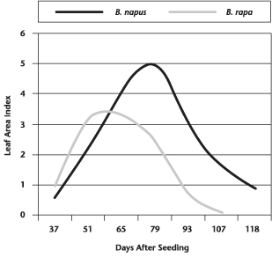
Figure 4. Relationship Between LAI and Crop Growth Rate
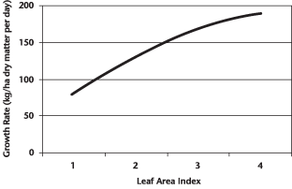
Researchers report that the maximum LAI for B. napus is between 3 and 6 while B. rapa averages 3.5. Leaves initially are the most important photosynthetic plant structure for fixing food for plant growth. The LAI of canola starts to decrease shortly after first flower (GS 60) (Figure 5). At full flower (GS 65), stems become the major photosynthetic structure although leaves are still important. At the beginning of ripening (GS 80) pod walls and stems account for the majority of photosynthesis while leaves make only a small contribution.
Figure 5. Photosynthetic Contribution by Canola Plant Structures
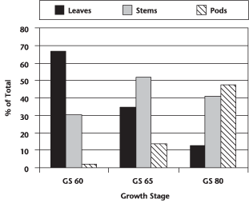
Plants in low population density crops (20 plants/m²) have a higher LAI than do plants in high population density crops (126 plants/m²). Plants compete with each other for light, moisture and nutrients. In uneven germinating crops the leaf area of early emerging plants can become large enough to cause weak, spindly growth or stunting and death of later emerging plants.
This growth stage (20-29) refers to the development of side shoots (tillering) and occurs in many plant species but it is not applicable to the spring canola varieties grown in Canada.
30 | stem elongation (bolting) begins
31 | stem 10% of final length
32 | stem 20% of final length
33 | stem 30% of final length
34 | stem 40% of final length
35 | stem 50% of final length
36 | stem 60% of final length
37 | stem 70% of final length
38 | stem 80% of final length
39 | maximum stem length
Stems display the leaves to sunlight and air. Canola plant stems are also important photosynthetic structures throughout the period of pod and seed growth (Figure 5).
Stem elongation (GS 30) overlaps leaf development and normally occurs earlier than GS 19. At or just prior to stem elongation, flower and branch initiation begins. Maximum stem length (GS 39) overlaps flower development and is reached at peak flowering (GS 65). As stems elongate, roots continue to grow deeper. The vegetative stages, or days from seeding to first flower, can range from 30 to 50 days in B. rapa and 40 to 60 days in B. napus, depending on date of seeding and growing conditions.
B. napus plants grow taller (75 to 175 cm, 30 to 70") on average than B. rapa plants (50 to 125 cm, 20 to 50"). Stem diameter and height are influenced by seeding date, moisture, variety, soil fertility and plant population. Plants in low-density crops have thicker stems and are more resistant to lodging. Plants in high-density crops are thinner and more prone to lodging. Lodging aggravates the problem of uneven pod maturity and creates an ideal microenvironment for the spread of diseases such as sclerotinia and alternaria. Disease infection reduces the photosynthetic capacity of the stems and pods, reducing yields.
This growth stage (40-49) is not important for canola management but applies in the development of harvestable vegetative plant parts such as broccoli or cauliflower.
50 | flower buds present, but still enclosed by leaves
51 | flower buds visible from above (green bud)
52 | flower buds free, level with the youngest leaves
53 | flower buds raised above the youngest leaves
55 | individual flower buds (main inflorescence) visible but still closed
58 | individual flower buds (secondary inflorescence) visible but closed
59 | first petals visible, but flower buds still closed (yellow bud)
Lengthening days and rising temperatures trigger bud formation. Flower development growth stages (GS 50-65) overlap stem development (GS 30-39). Initially flower buds (GS 50) remain enclosed during early stem elongation (GS 31) and can only be seen by peeling back young leaves. As the stem elongates a cluster of flower buds can be easily seen from above but are still not free of the leaves. This is known as the green bud stage.
As the stem rapidly bolts or lengthens, the buds become free of leaves and the lowest flower stalks extend so that the buds assume a flattened shape. The remaining leaves attached to the main stem unfold as the stem lengthens and the small stalks holding the first unopened flower buds become more widely spaced. The lower flower buds are the first to become yellow, signalling the yellow-bud stage.
Secondary branches arise from buds that develop in axils of upper leaves and occasionally from axils of some lower leaves on the main stem. These secondary branches develop one to four leaves and a flower bud cluster. The canola plant initiates many more inflorescences (branches with flower clusters) than it can support, then aborts back according to the plant's set carrying capacity and environmental conditions. The ability to produce secondary branches is useful as it allows the crop to compensate for poor stand establishment and damage due to hail, pests and diseases. Development of branches is not fixed until the end of flowering. Removal of branches by hail can initiate replacement. Environmental stress can reduce the degree of branching and if the second to fourth primary branches (from the top) are affected, total flower production and therefore total seed yield can be seriously reduced.
B. rapa plants usually develop many branches. In an average uniform stand, plants can average eight to nine branches per plant. Individual plants in this type of stand will produce three to 20 branches. The greater number of branches leads to a less structured appearance. This makes identification of the main stem more difficult in the mature B. rapa plant.
B. napus plants grow taller and have a distinct main stem with fewer secondary branches. B. napus plants, in an average uniform stand, will average from four to six branches per plant. However, individual plants can range from two to nine branches. Low plant populations produce more branches per plant compared to high plant populations.
The main stem reaches 30 to 60% of its maximum length just prior to flowering. Also, 30 to 60% of the plant's total dry matter production will have occurred at this time, depending upon growing conditions (Figures 6 and 7).
Figure 6. Canola Plant Dry Weight Distribution - B. napus (Lethbridge, AB Irrigation)
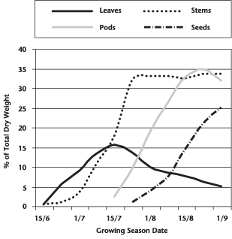
Figure 7. Canola Plant Dry Weight Distribution - B. rapa (Lethbridge, AB Irrigation)
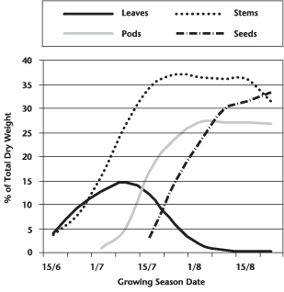
Maximum leaf area is usually reached near the beginning of flowering and then begins to decline with the loss of lower leaves. The leaves, especially the upper ones at this stage, are the major source of food for the growth of stems and buds. Rapid development and growth of a large leaf area, which is maintained well beyond the start of flowering, strongly influences pod set and early seed development on the main stem and the first few secondary branches. This impact of leaves on potential yield is shown in the results of a study at the Saskatoon, SK Agriculture and Agri-Food Canada Research Centre where leaves were removed at three flowering stages (Figure 8).
Figure 8. Reduced Yield Due to Leaf Area Loss at Different Growth Stages
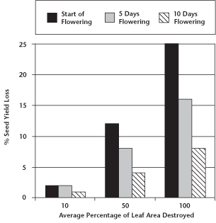
Leaves at the start of flowering are the major source of food for plant growth, and their removal results in a large seed yield loss. As flowering progresses, the leaf area declines and becomes less important as a source of food for plant growth, and its removal results in less seed yield loss (Figure 5).
The development and maintenance of a large leaf area after the start of flowering is largely dependent on proper seedbed preparation combined with adequate moisture, temperature and nutrients that promote rapid, uniform emergence and growth.
60 | first flower opens
61 | 10% of flowers on the main raceme open, main raceme elongating
63 | 30% of flowers open on the main raceme
65 | full flowering - 50% of flowers on main raceme open, older petals falling
67 | flowering declining - majority of petals fallen
69 | flowering ends
B. napus varieties are self-pollinated and do not need pollinating agents such as wind and insects. About 70 to 80% of the seed produced is from self-pollination. The crop is very attractive to bees but their presence is unlikely to have much effect on yield. However, some research has reported that bees cause seed set to occur earlier, resulting in shorter, more compact plants that ripen more uniformly.
B. rapa is highly self-incompatible and relies on crosspollination from other plants. Bees are the main pollinating agents, assisted by other insects and by wind. If adequate pollination does not occur, yield can be significantly affected.
The two species can be distinguished at flowering by the position of the buds to the surrounding open flowers (Figure 9).
Figure 9. Distinguishing Characteristics of Some Brassicas
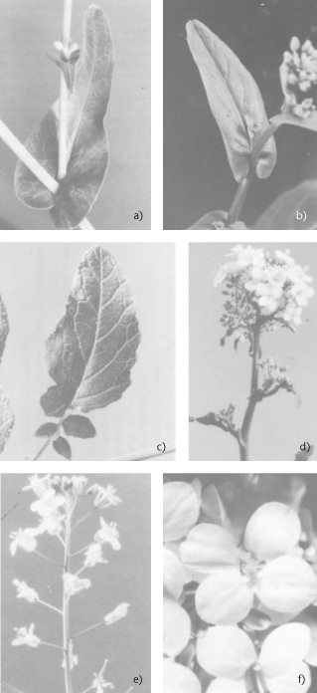
a) B. rapa - blade of upper leaves fully clasp the stem
b) B. napus - leaves partially clasp the stem
c) B. juncea - leaf blade terminates well up the petiole
d) Flower cluster of B. rapa with buds below open florets
e) Flower clusters of B. napus with buds above open florets
f) Typical Brassica floret
Copyright by Academic Press Canada, 1983
The flower bud clusters are more compact in B. rapa. In B. napus, the buds are normally borne above the open flowers, while in B. rapa, the buds are held below the uppermost open flowers. B. rapa flowers are normally smaller and darker yellow than B. napus flowers. The shape of the leaves on the flowering stalk can also be used to distinguish between the species (Figure 9). In B. rapa, the upper leaf blade clasps the stem completely, while in B. napus the leaf only partially clasps the stem. In tame and wild mustard plants, the leaf blade terminates well above the stem.
Flowering begins with the opening of the lowest bud on the main stem and continues upward with three to five or more flowers opening per day. Flowering at the base of the first secondary branch begins two to three days after the first flower opens on the main stem. Figures 10 and 11 illustrate the progression of flowering in fields of B. rapa and B. napus with uniform stands of average density.
Figure 10. Days to Flower and Duration of Individual Branches - B. rapa Seeded May 25
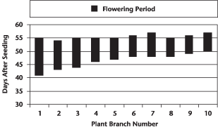
Figure 11. Days to Flower and Duration of Individual Branches - B. napus Seeded May 5
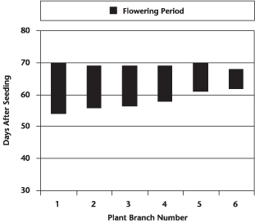
Under reasonable growing conditions, flowering of the main stem will continue from 14 to 21 days for both species. Full plant height (GS 39) is reached at peak flowering (GS 65) due to the overlap of growth stages.
Flowers begin opening early in the morning and, as the petals completely unfold, pollen is shed and dispersed by both wind and insects. Flowers remain receptive to pollen for up to three days after opening. If favourable, warm, dry weather occurs, nearly all the pollen is shed the first day the flower opens. In the evening, the flower partially closes and opens again the following morning. Fertilization occurs within 24 hours of pollination. After pollination and fertilization, the flower remains partially closed and the petals wilt and drop (two to three days after the flower opened). The young pod becomes visible in the centre of the flower a day after petals drop.
During flowering, the branches continue to grow longer as buds open into flowers and as flowers develop into pods. In this way, the first buds to open become the pods lowest on the main stem or secondary branches. Above them are the open flowers, and above them, the buds which are yet to open. All of the buds that will develop into open flowers on the main stem will likely be visible in B. napus within three days after the start of flowering, and within 10 days in B. rapa.
Canola plants initiate more buds than they can develop into productive pods. The flowers open, but the young pods fail to enlarge and elongate, and eventually fall from the plant (Figure 12).
Figure 12. Total Flowers Produced and Productive Pods Formed in B. napus Plants
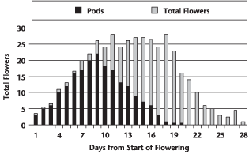
The abortion of flowers and pods is natural. Both flowers and seeds can undergo substantial abortion depending on the carrying capacity established by leaf, stem and branch growth plus environmental stress imposed during flowering and seed set. During flowering the plant can adjust yield based on the number of flowers produced and pollinated. Under stress, the number of branches that produce flowers may be reduced and the number of flowers on each branch may decline. Flowers that are open during heat stress may fail to pollinate. Normally, fertility of flowers that open later will be unaffected if stress has been alleviated. Areas on the main stem or branches with no pod development are symptoms of stress. Under severe stress, loss of unopened buds increases, signalling the end of flowering. If the severe stress occurred at early flowering the plant may resume flowering through increased branching if very favourable conditions return.
Studies at the Agriculture and Agri-Food Canada Saskatoon Research Centre have shown that only 40 to 55% of the flowers produced on a plant develop productive pods, which are retained until harvest (Figure 13). In this study, conducted in a dry year, most of the productive pods were from flowers that opened within the first 15 days of flowering on the main stem and first three secondary branches. Later flowers and pods on all branches aborted. Under more favourable growing conditions more flowers and pods would have been produced but the percentage of abortions would have been similar.
Figure 13. Number of Flowers for each Branch and Number of Productive Pods in B. rapa
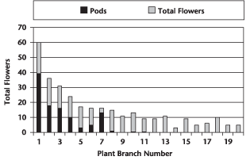
At the peak of flowering canola produces a bright yellow layer of flowers, at least 30 cm (12") thick, which forms an effective reflecting and absorbing surface for solar radiation at the top of the crop. Studies have found that flowers reflect or absorb about 60% of incoming radiation that could have been utilized by the photosynthetic active tissues of the plant. Research studies comparing a normal flowering variety with an apetalous variety at peak flowering have shown that solar radiation into the canopy increased by 30% when plants had no flower petals. The main reason for the decrease in leaf area index (LAI) after floral initiation is the reduction of radiation into the leaf canopy caused by flower petals. This shading results in senescence of active green leaves. Therefore, apetalous varieties should have a greater photosynthetic capability through increased radiation into the crop canopy at the critical stage for developing pods and seeds.
70 | 0% of pods reach final size
71 | 10% of pods reach final size
72 | 20% of pods reach final size
75 | 50% of pods reach final size
77 | 77% of pods reach final size
79 | nearly all of the pods reach final size
By mid-flower, when lower pods have started elongating, the stem becomes the major source of food for plant growth, with a reduced amount from the declining leaves and a small amount from the developing pods (Figure 5). There is competition for the food supply between flowers and pods on the same branch, as well as between branches. The early developed pods have a competitive advantage over later formed pods. Flowering on the later developing secondary branches may continue for some time after the main stem has finished flowering. Older pods at the base of the flowering branches are well along in development while new flowers are still being initiated at the tips. At this stage, the stem and pod walls are both major sources of food for seed growth since the pod photosynthetic surface area has greatly increased (Figure 5).
During the first couple of weeks of seed development, the seed coat expands until the seed is almost full size. The seed at this stage is somewhat translucent and resembles a waterfilled balloon. The seed's embryo now begins development and grows rapidly within the seed coat to fill the space previously occupied by fluid; seed weight increases.
Any stress leading to a change in the supply of food can abort pods or reduce the number of seeds in each pod. The stress may be internal where the plant is unable to take up soil water available to it or to generate food supplies necessary for seed filling. The stress can be external where soil water is limited or temperatures excessive for optimal crop development.
The number of seeds that develop in each pod will be influenced by the availability of plant food supplies at the time when seed expansion occurs. Lack of plant food supplies at this growth stage will result in smaller pods with fewer, lighter seeds, especially in the later secondary branches and tops of branches. Substantial stress at seed expansion leads to shorter pods and/or lack of expansion around missing seeds. Segments of the pods will not expand normally with little or no sign of seed remnants inside the pod.
Plants under stress redirect food supplies from stems and pods to those seeds that are left. The only way a plant can respond to more favourable conditions late in the growing season is by producing larger seeds. When severe stress occurs later in the filling process, the pod appears normal because the seed expanded normally and then started to die off resulting in a shrivelled seed coat with little or no evidence of having started the seed filling process.
Once seed expansion is complete, seeds are more resistant to loss from stress, but losses can occur if stress is severe. The plant attempts to redirect food supplies to seeds that continue filling. Pods show no external signs of stress, but affected seeds may be visibly shrivelled within the pod. Even where shrivelling is not evident, due to reduced food supplies, seed size will be smaller and a larger portion of seeds will have wrinkled seed coats. B. rapa is reported to be more sensitive to high temperatures, while B. napus is more sensitive to drought.
B. napus pods are larger, with a medium length beak, while B. rapa pods are smaller and shorter, with a long beak (Figure 14). The pod is divided internally into two halves by a membrane, which runs the full length of the pod. Normally a pod contains 15 to 40 seeds. B. napus seeds are generally larger at 3.5 to 5.5 grams/1,000 seeds (182,000 to 286,000 seeds/kg or 83,000 to 130,000 seeds/lb) than B. rapa at 2.0 to 3.0 grams/1,000 seeds (333,000 to 500,000 seeds/kg or 150,000 to 227,000 seeds/lb).
Figure 14. Typical Pods of B. napus and B. rapa Canola
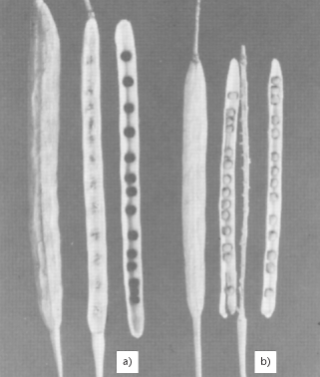
Typical pods of:
a) B. napus showing an intact and opened pod with the seeds of the upper half exposed, while those of the lower half are obscured by the central membrane;
b) an intact and opened pod of B. rapa
80 | ripening begins - seed green, filling pod cavity
81 | 10% of pods ripe, seeds black and hard
83 | 30% of pods ripe, seeds black and hard
85 | 50% of pods ripe, seeds black and hard
87 | 70% of pods ripe, seeds black and hard
89 | fully ripe - nearly all pods ripe, seeds black and hard
At the stage where seeds in the lower pods have turned green, most of the leaves on the plant have yellowed and fallen from the plant. The pod walls have become the major source of food although the stem is still important (Figure 5). The pods, besides being major food producers, are also major food users from other sources for seed development.
About 35 to 45 days after the flower opens seed filling is complete. The firm green seed has adequate oil and protein reserves to support future germination and seedling growth. The stems and pods turn yellow and progressively become brittle as they dry.
Usually the earliest formed pods are the largest and develop more and larger seeds. Immature seeds, when filled, contain about 40 to 45% moisture. The seed coat then begins to turn from green to yellow or brown, depending on the variety. Seed moisture is rapidly lost at a rate of 2 to 3% or more per day, depending on growing conditions. At 40 to 60 days after first flower or 25 to 45 days after the end of flowering, the seeds in the lower pods will have ripened and fully changed colour. As the seed coat changes colour so does the seed. The embryo, which fills the entire seed, begins to lose its green colour. When completely mature the seed is uniformly bright yellow in colour. When 30 to 40% of the seeds on the main stem of a plant have begun to change seed coat colour (black or yellow), seeds in the last formed pods are in the last stages of filling. The majority of seeds have reached physiological maturity and the average seed moisture is about 30 to 35%. This is the optimum stage for swathing. Swathing before physiological maturity can result in reduced yields due to incomplete seed development.
Although the potential number of pods per plant and seeds per pod are set at flowering, the final number is not established until a later stage. Seed filling requires adequate soil moisture and nutrients. Seed abortion, or reduction in seed weight, can be caused by anything that interferes with plant functions during this time.
In canola, the seed accounts for about 23 to 31% of the total plant dry matter produced, depending upon growing conditions (Figures 6 and 7). The leaves, stems and especially pod surface areas must be kept free from disease, insect and weather damage. Anything that stresses or reduces the food production capacity of these plant surfaces may lead to a reduction in seed yield.
92 | plants dead and dry
95 | plants dead and dry
97 | plants dead and dry
99 | harvested product
When all the seeds in all pods have changed colour, the plant dies. Mature pods easily shatter (split along the centre membrane) and the seed is lost. B. rapa pods are more resistant to shattering than the easily shattered B. napus pods. This and other characteristics of B. rapa versus B. napus canola are summarized in Table 1.
Table 1. Summary of the Chief Characteristics of B. rapa and B. napus.
Characteristic | B. rapa | B. napus
Cotyledons | Hairy and wrinkled on underside | Smooth on underside
Rosette and leaves | Small, 3 to 5 yellowgreen leaves | Larger, up to 6 waxy, blue-green leaves
Branches | Up to 20 per plant | 4 to 6 per plant on average
Flowers | Smaller, darker yellow, rely on cross pollination. Compact bud clusters, buds held below uppermost open flowers | Self-pollinating, buds borne above open flowers
Leaves | Leaf blade clasps the stem completely | Leaf blade only partially clasps the stem
Height | 50 to 125 cm (20 to 50") | Taller, 75 to 175 cm (30 to 70")
Pods | Smaller, shorter, long beak, smaller seeds, more pods | Large, medium length beak, fewer pods, larger seeds
Shattering | Resistant | Easily shattered
The life cycle of the canola plant is divided into seven principle stages. Learn the growth stages to make the critical management decisions at each development stage. Each growth stage covers a stage in the development of the plant. However, the beginning of each stage is not dependent on the completion of the preceding stage. Several growth stages tend to overlap. From the onset of budding each growth stage is determined by examining the main flowering (terminal) stem. The timing and occurrence of the different growth stages will vary with growing conditions, location, species and variety. When two stages overlap, use the growth stage number for the more advanced stage, where it will adequately describe the state of the plant.
In general, the growth stages of the canola plant and overlaps are illustrated in the following chart:
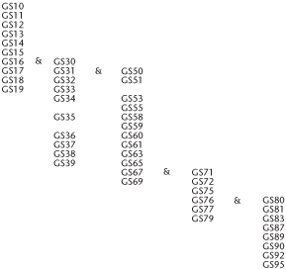
Maturity, or days from seeding to harvest, is an overall measure of the duration of canola growth stages. Maturity will vary considerably depending on location, growing season and date of seeding (Table 2). Generally speaking, B. rapa varieties mature seven to 28 days earlier than most B. napus varieties.
Table 2. Range in Maturity at Different Research Trial Locations and Years
Location | Range in Days from Seeding to Swathing
 | B. rapa |  |  | B. napus
 | Low | Avg | High | Low | Avg | High
Ontario
Guelph | 77 | 79 | 81 | 84 | 86 | 88
Kempville | 73 | 80 | 86 | 84 | 88 | 92
New Liskeard | 78 | 85 | 100 | 92 | 105 | 129
Kapuskasing | 76 | 96 | 111 | 96 | 116 | 140
Manitoba
Morden | 66 | 80 | 99 | 83 | 94 | 105
Winnipeg | 70 | 81 | 88 | 74 | 96 | 105
Brandon | 66 | 82 | 106 | 78 | 93 | 124
Portage La Prairie | 67 | 47 | 85 | 79 | 89 | 99
Saskatchewan
Regina | 75 | 85 | 93 | 96 | 99 | 105
Watrous | 77 | 80 | 82 | 85 | 88 | 90
Saskatoon | 85 | 87 | 90 | 94 | 98 | 100
Indian Head | 78 | 87 | 96 | 89 | 103 | 114
Scott | 83 | 88 | 96 | 97 | 101 | 106
Melfort | 75 | 88 | 100 | 95 | 105 | 112
Alberta
Lethbridge | 69 | 72 | 81 | 88 | 89 | 90
Irricanna | 86 | 89 | 90 | 96 | 99 | 102
Olds | 98 | 104 | 110 | 107 | 113 | 120
Penhold | 95 | 98 | 104 | 102 | 105 | 108
Lacombe | 91 | 97 | 106 | 102 | 118 | 127
Ellerslie | 91 | 95 | 99 | 101 | 107 | 113
Westlock | 89 | 91 | 107 | 98 | 105 | 112
Kelsey | 81 | 98 | 111 | 100 | 106 | 114
Vermilion | 89 | 93 | 109 | 95 | 98 | 104
Beaverlodge | 84 | 96 | 108 | 103 | 119 | 133
Fort Vermilion | 88 | 94 | 100 | 106 | 116 | 130
Since the mid-1990s, increasing numbers of new canola varieties have been introduced to the market. Some of these are adapted to specific canola growing regions. Check with your provincial oilseed extension specialist or refer to reports of adaptation trials in your province to determine what varieties have the maturity best suited to your area. Varieties that require fewer days to mature can be grown in the southern canola growing areas because of the greater heat units available. In the far north, the longer day length tends to offset the lower heat units available.
http://www.canolacouncil.org/crop-production/canola-grower's-manual-contents/chapter-3-growth-stages/growth-stages.
http://www.canolacouncil.org/crop-production/canola-grower's-manual-contents/chapter-3-growth-stages/growth-stages

